**Module 1:- Hardware**

1. **Section 1: Multiple Choice**
2. **Which of the following is NOT a component of the CPU?**
   1. **Answer:** 2. RAM
3. **What is the function of RAM in a computer?**
   1. **Answer:** RAM (Random Access Memory) temporarily stores data and instructions that are actively being used or processed by the CPU. It provides fast access to data, improving system performance.
4. **Which of the following is a primary storage device?**
   1. **Answer:** 4. 1 and 2 both (HDD and SSD)
5. **Section 2: True or False**
6. **What is the purpose of a GPU?**
   1. **Answer:** A GPU (Graphics Processing Unit) is designed to handle rendering and manipulating images, videos, and animations. It enhances the computer’s ability to display high-quality graphics and accelerate computation-heavy tasks like gaming or video editing.
7. **True or False: The motherboard is the main circuit board of a computer where other components are attached.**
   1. **Answer:** **True**
8. **True or False: A UPS (Uninterruptible Power Supply) is a hardware device that provides emergency power to a load when the input power source fails.**
   1. **Answer:** **True**
9. **True or False: An expansion card is a circuit board that enhances the functionality of a component.**
   1. **Answer:** **True**
10. **Section 3: Short Answer**
11. **Explain the difference between HDD and SSD.**
    1. **Answer:**
       1. **HDD (Hard Disk Drive):** Uses spinning disks to read and write data. It is generally slower and more prone to damage due to moving parts.
       2. **SSD (Solid State Drive):** Uses flash memory to store data, which makes it faster, more durable, and quieter compared to HDDs.
12. **Describe the function of BIOS in a computer system.**
    1. **Answer:** BIOS (Basic Input/Output System) is a firmware that initializes hardware components during the boot process and provides an interface between the operating system and the hardware.
13. **List and briefly explain three input devices commonly used with computers.**
    1. **Keyboard:** Used to input text and commands into the computer.
    2. **Mouse:** Allows users to point, click, and navigate the computer interface.
    3. **Scanner:** Converts physical documents into digital format for editing or storage.
14. **Section 4: Practical Application**
15. **Identify and label the following components on a diagram of a motherboard:**
    1. **Answer:**
    2. 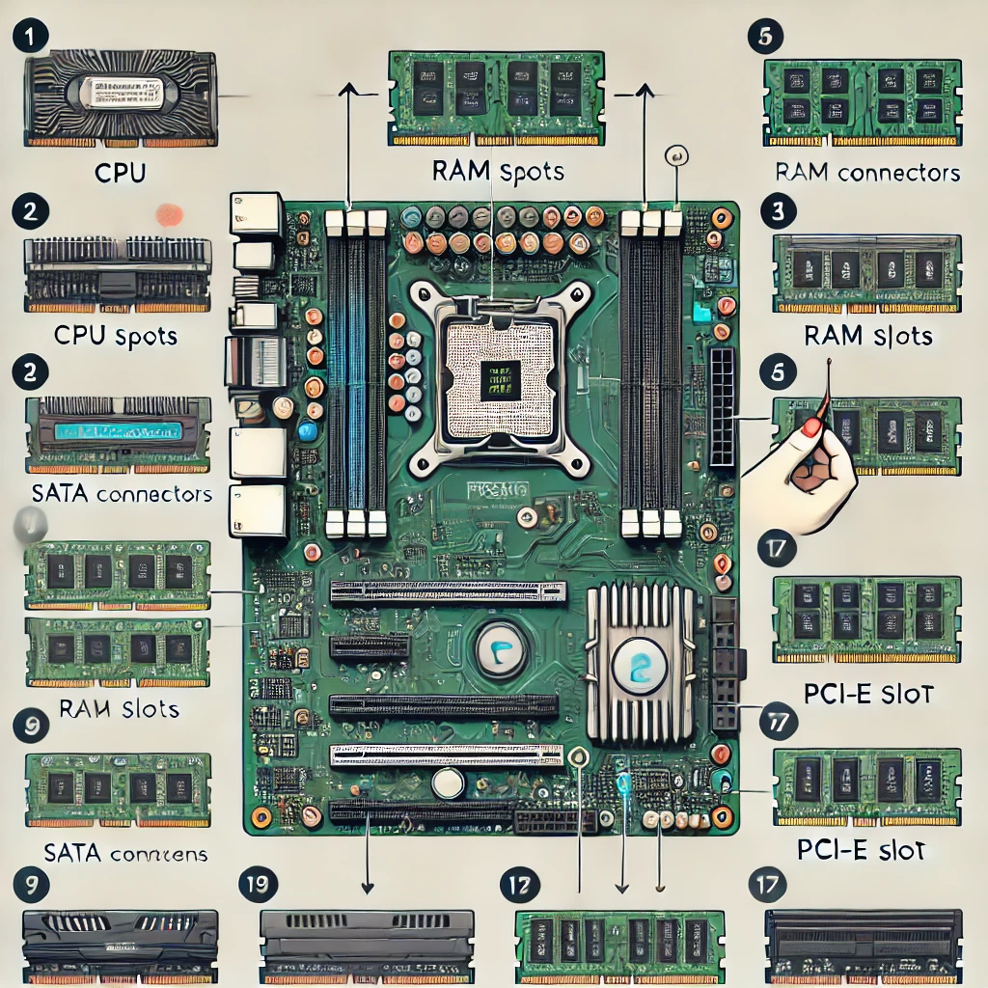
       1. **CPU:** Central Processing Unit, typically located in the socket area.
       2. **RAM slots:** Long, thin slots near the CPU for inserting RAM modules.
       3. **SATA connectors:** Small, L-shaped connectors near the bottom of the motherboard for connecting storage devices.
       4. **PCI-E slot:** A long slot used for expansion cards like GPUs.
16. **Demonstrate how to install a RAM module into a computer.**
    1. **Answer:**
       1. Turn off the computer and unplug it from the power source.
       2. Open the computer case.
       3. Locate the RAM slots on the motherboard.
       4. Align the notch of the RAM module with the slot.
       5. Insert the RAM module at a 45-degree angle, then press down gently until it clicks into place.
       6. Close the case and power on the computer.
17. **Discuss the importance of proper cooling mechanisms in a computer system. Include examples of cooling methods and their effectiveness.**
    1. **Answer:** Proper cooling is crucial to prevent overheating, which can lead to hardware failure and performance degradation. Cooling mechanisms include:
       1. **Air cooling:** Fans and heat sinks that dissipate heat. Effective for most systems, cost-effective, and easy to maintain.
       2. **Liquid cooling:** Uses a liquid coolant to absorb heat and transfer it away. More efficient for high-performance systems but more expensive and complex.
       3. **Thermal paste:** Applied between the CPU and cooler to improve heat transfer.
18. **Explain the concept of bus width and its significance in computer architecture.**
    1. **Answer:** Bus width refers to the number of bits that can be transmitted simultaneously over the system's data bus. A wider bus allows more data to be transferred at once, improving overall performance. It affects the system's speed, especially when dealing with large amounts of data.